DEVELOPING A SNAPSHOT
An Activity Guide to
Communicating Value and Impact
Milestone 1
Milestone 2
Milestone 3
November 2020

About
The Demonstrating Value Initiative is a collaboration of community sector organizations united by the common interest of developing more accessible performance measurement and impact assessment methodologies for community The initiative, led by Vancity Community Foundation, engaged 20 social enterprises and investors between 2007-2009 in a process to develop and pilot a measurement framework. The framework has since been adapted to meet the needs of non-profit organization more broadly.
The initiative received financial and technical support from the following organizations: Coast Capital Savings, Community Economic Development Technical Assistance Program (CEDTAP), Enterprising Non-Profits (enp), Human Resources and Social Development Canada (HRSDC) and Renewal Partners, SAP Canada and Vancity Credit Union.
This guide and other tools that are available on the Demonstrating Value website are based on this framework. In 2013, a non-profit society, the Demonstrating Value Resource Society, was set up to extend the work of the Demonstrating Value Initiative.
This guide, initially known as the Demonstrating Value Workbook, was developed by Bryn Sadownik and has been updated over the past 10 years. In 2020, it was separated into two complementary resources: Developing a Snapshot and Performance and Impact Measurement.
Further copies can be downloaded at www.demonstratingvalue.org.

Guide Contents
Introduction 1
Step 1: Define the Audience for your Snapshot 4
Step 2: Develop a Vision of your Snapshot 6
Different Types of Snapshots 6
Develop your Snapshot 6
Step 3: Develop the Content of your Snapshot 8
Step 4: Design your Snapshot 14
Design Tools 16
Step 5: Using and Improving your Snapshot 20
NOTES 23
APPENDIX A 24

List of Worksheets

WORKSHEET A: Identify the potential audiences for the Snapshot. 5
WORKSHEET B. Develop a Vision of your Snapshot 7
WORKSHEET C: What Do You Want to Know and Show? 13
WORKSHEET D: Data Development Plan 22

Introduction
Demonstrating Value can help you take control of the data you collect, how it is used and to communicate the performance and value of your organization, social enterprise or program. In this activity guide, you will design a ‘Snapshot’ communications tool that will provide an engaging summary of performance and value. This will help you:
- Save valuable time finding and pulling together data and other information for reports.
- See key trends and relationships in data, so you can get the most from the data you collect.
- Combine different types of information effectively to engage your audience.
- Provide you with a clear picture of resources, efforts and results to help you plan and manage your day-to-day activities, demonstrate your value to others and ensure the long-term sustainability of your organization.
Developing the Snapshot, involves the following steps:
- Define your Audiences and their Needs
- Develop a Vision of your Snapshot
- Develop the Content of your Snapshot
- Design your Snapshot
- Using and Improving your Snapshot
We recommend working through this activity guide with a cross-section of people involved in your organization (or initiative). You can do this in a workshop, a series of meetings or through targetted consultations. This activity guide can be used by itself or in conjunction with Demonstrating Value’s other Getting Started Toolkit resource: Performance and Impact Measurement: Improving your Practices. www.demonstratingvalue.org.
This complementary guide can be used to support you in systematically assessing: 1) what information you need to run your organization (or implement and initiative), 2) how you are collecting it, and 3) how you can make the most use out of it. Use both activity guides if you have the time and desire to improve underlying performance and impact measurement while also developing a Snapshot.

What is a Snapshot?
A Snapshot is a communication tool that you can use to present the performance and value of your organization, program or project to boards, investors/funders and staff. It is tailored to your needs and the audiences you want to connect with, and can take the form of an Infographic, Dashboard or Impact Report. Examples of Snapshots can be found at: www.demonstratingvalue.org/snapshots
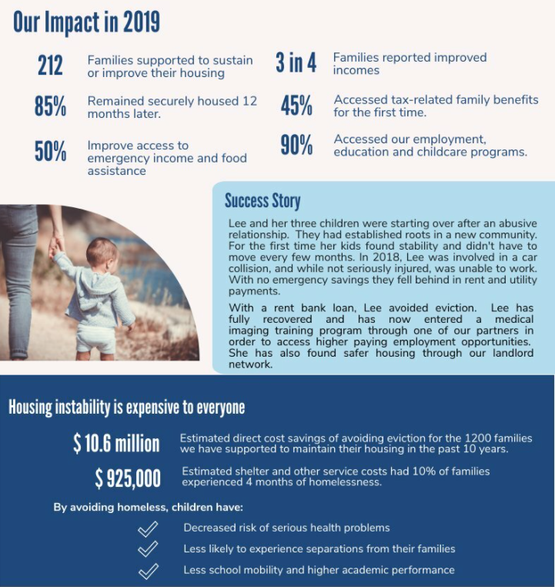
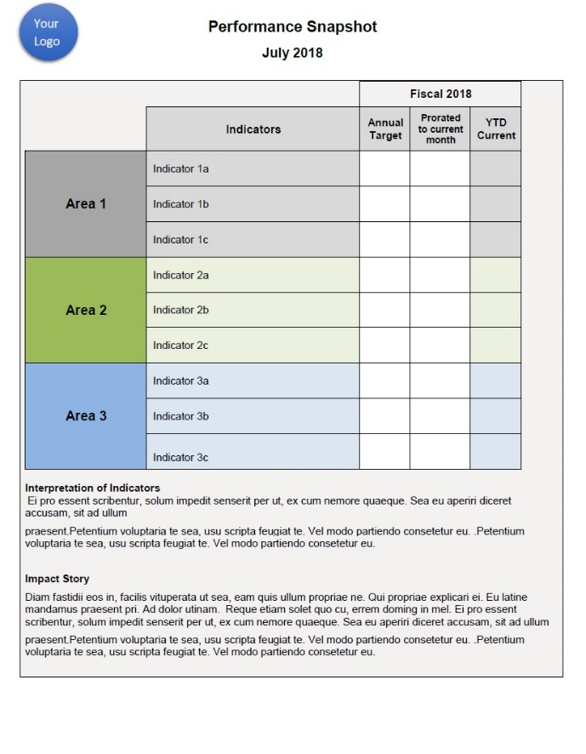
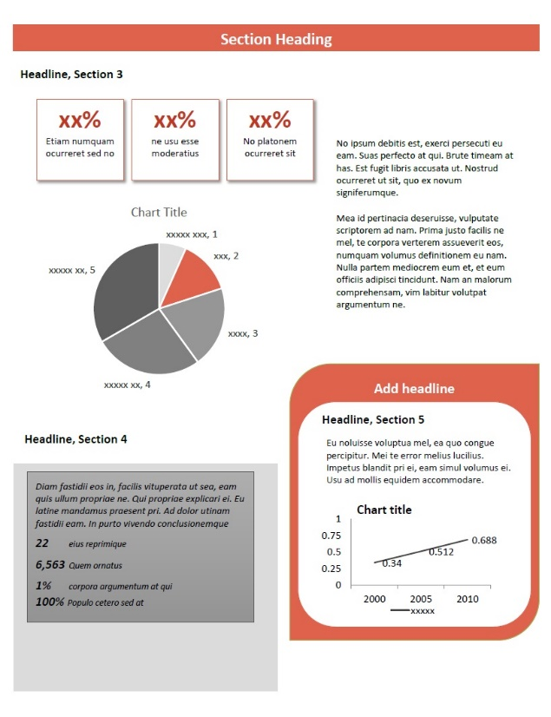
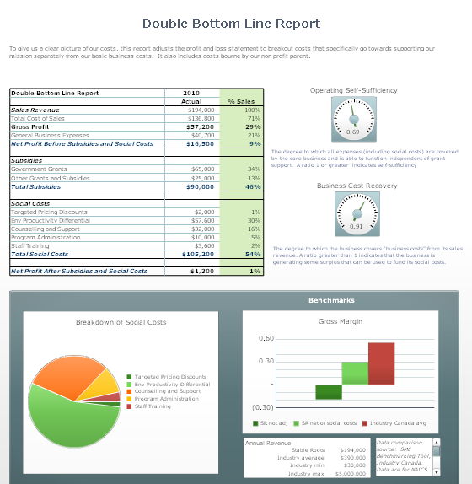

The exact content and format of the Snapshot depends on who you want to reach and the issues that are important. For example, the layout and content for a bi-monthly board presentation might be very different from a Snapshot designed to be part of your public website to engage volunteers and donors.

The Common Approach to Impact Measurement
Demonstrating Value’s framework fits in with the Common Approach to Impact Measurement, a new, developing standard for impact measurement in Canada. This is a flexible standard that provides a foundation for sector-wide impact measurement and reporting. By using Demonstrating Value to strengthen your measurement capacity, you are also implementing the Common Approaches, and positioning your organization for impact investments, gaining new value-driven customers, and reporting more easily to your Board or funder.
Where relevant in this workbook and other Demonstrating Value Resources, we reference the Common Approaches using the Circle Icons below that can easily allow you to connect with other Impact Measurement resources that are also aligned with the Common Approach. You can learn more about the Common Approach at their website: https://carleton.ca/commonapproach/common-foundations

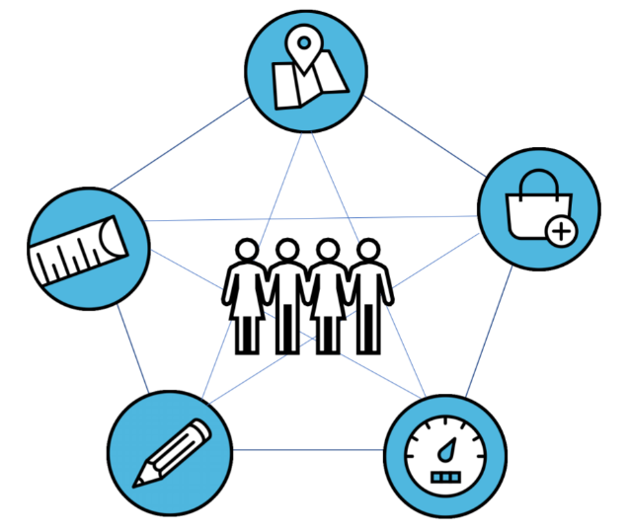
Plan your change
Use performance measures
Collect useful information
Gauge your impact
Report on results

Step 1: Define the Audience for your Snapshot
Your organization is important for many different groups of people, and in different ways. These are your stakeholders who are also the likely audiences for your Snapshot. Understanding who these people are, and what they care about, is critical for developing effective reporting. Common audiences for your Snapshot include:
- Employees
- Volunteers
- Management
- A governance body (e.g. Board of Directors)
- Constituent group (i.e. those in whose name you are working)
- Customers
- Investors, funders, donors
- Peers and partners
- The community at large
In developing any communications tool, you must think of the intended purpose of the document and what the data and other information within it will be used for. The purposes of a Snapshot may be to:
- Support operational decision-making
- Guide strategic direction
- Show accountability to investors/funders
- Increase knowledge
- Challenge conventional narratives (about an issue)
- Inspire and maintain (funding) support
- Motivate action
- Communicate succinctly

Use Worksheet A to identify your stakeholders and what the purpose of the Snapshot would be for them.

WORKSHEET A: Identify the potential audiences for the Snapshot.
Identify the potential audiences for the Snapshot.
Don’t be too specific or name individual people. Rather think of the key groups of people that matter in and around the organization (e.g. Board of Directors, Key Partners, Executive Team, Management, Volunteers, Clients, Customers, Community-at-large, Main Funders etc.)
Audience | Snapshot purpose (e.g. will it support decision-making, fundraising, etc.?)
Add in more rows as needed.

Step 2: Develop a Vision of your Snapshot
The design process for a Snapshot includes thinking about who the audience is, what decisions they are making, the messages you want to convey, and the information you will present (which can include numeric, narrative, pictures and other types of information). The starting point is to first develop a vision of what your Snapshot will look like. You can look at examples of Snapshots in the Snapshot Gallery at www.demonstratingvalue.org/snapshots

Different Types of Snapshots
Snapshots vary in terms of the visual elements that they include and how they balance text and numerical information. Typical forms are Dashboards, Infographics and Impact Reports. Any of these can be presented as a printed/PDF document or can be web-based.
Dashboard
A Dashboard displays indicators (i.e. performance measures, metrics and data points) for an organization, department, team or process. It is typically an internal tool that is directed to management, a senior executive team or an advisory/governance board. Indicators are organized around objectives and include key performance indicators (‘results’) and key success factors (‘what drives the results’).
Infographic
An Infographic is a representation of information that is graphically designed to make data easily understandable at-a-glance. It is mainly used as a communication tool to external audiences, often as a small poster that can be displayed. The information is presented in a fun and eye-catching way.
Impact Report
An Impact Report may be a section of an annual report or a stand-alone report that clearly communicates your mission and impact. The length can range from a few pages to more than a dozen; you can go into more detail about your impact than in an Infographic. The information is still presented in an eye-catching way with a balance of photographs, figures, metrics and text. It is mainly directed to an external audience.

Develop your Snapshot
What kind of Snapshot would you like to develop? Use Worksheet B on the next page to describe what you need. While you may want to develop more than one type of Snapshot and to develop Snapshots for different initiatives and audiences, start with the one that is most important to you.

WORKSHEET B. Develop a Vision of your Snapshot
1) What is the scope of the Snapshot? Will it be for the whole organization, a specific program, initiative or project?

2) Who is the key audience for this Snapshot? Are there others?

3) Will it be a Dashboard, Infographic or Impact Report?

4) Select a Preliminary Snapshot Design(s)
View designs on the DV Snapshot Examples webpage or search for examples of Infographics, Impact Reports and Dashboard for similar organizations on the Internet.
Names and website addresses of the designs that we like:
What do you like and dislike about these designs? What things would you change?

Step 3: Develop the Content of your Snapshot
In this step you will work out the content of your Snapshot. This focuses on identifying what you want to convey in your Snapshot, and how you will convey it.
A Snapshot is tailored to your needs and the audiences you want to connect with in essence, you need to think about the evidence-based story you want to tell and the decisions that can be better supported by data.
As described in Step 1, there are Snapshots that support operational or strategic decision-making (e.g. a Dashboard) and others that are more geared to supporting communications and engagement (e.g. an Impact Report or Infographic). The content for both shares much in common, but the details included and how you may want to present the information differs. We look at each in turn.

A Dashboard
A Snapshot that supports decision-making is often referred to as a Dashboard. Some organizations also like to use the term Scorecard. It serves to focus an executive team, management, governance body, staff, or team on the implementation of a strategic or operational plan that includes specific objectives that are expressed as performance measures. An example of a Snapshot is shown on the next page for fictitious social enterprise that employs youth in landscaping. You will notice that there are some efforts to group performance measures by theme, and to contextualize results to the previous period and to a target.
Often performance measures are identified as part of a program, business or organizational planning processes, or they may have been articulated as part of a funding application, contract or evaluation. These measures may be good content for your Dashboard, if they relate directly to what you want to understand, learn and convey. When faced with the demand for measurable goals in funding application forms, measures and targets can be developed quite hastily, or they may be imposed and not reflect necessarily the full impact and value that you create.
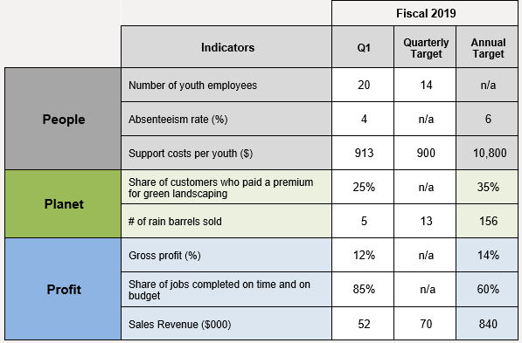

To develop the content of your Dashboard, go through the process of defining:
- What do you want to know?
- How will you show it?
In general, you need to determine the performance measures and other evidence you include in your Dashboard that supports decision-making. Box 1 below provides tips on defining the content for a dashboard. Use Worksheet C on page 13 to develop your content in this way. A couple examples are shown here.
What do you want to know? | How will you show it?
Are we connecting people to supports that they need to succeed? | - # of referrals by type of referral  - % of people that followed up  - % that found referral useful
Are we developing enduring relationships with customers? | - % customers with a relationship >x years (customer loyalty)  - % willingness to reorder  - # returning customers

BOX 1. CONTENT DESIGN TIPS FOR DASHBOARDS
- Targets can be a useful tool to foster learning and inspire performance. Many Dashboards will score a performance measure based on the degree to which a target is met, using stoplight colour coding. If you do this, set a target around something that is largely within your sphere of control and ensure that it is useful and achievable. It may be worth holding off on setting targets until you have baseline or benchmarking data to know what is possible.
- Think about how this Dashboard relates to decision-making. Not everything that can be measured is important, and not everything that is important can be measured. How will you ensure that information that may not be easily quantifiable, but which may yield important insights, is also included in decision making?
- Think ‘outside the box’ and ‘outside your bubble’. If factors outside of your direct control have a significant influence on achieving a goal, it could be useful to track them.
- Do not limit your performance measures to showing only what is going on. Try to include some measures that can provide insight into why something is happening and what may drive future performance.
- The number of measures should balance your need to get the best insights possible with the resources you have available. Take the time to think critically about what you are measuring and be flexible to update measures to reflect organizational changes. Be open to adding indicators to help understand underlying dynamics that led to the result if needed.
- Once you have a Dashboard, you will need to refine them in practice. Many organizations reduce the number of indicators they collect because they realize some are more important than others; some are too hard to collect; or they missed the mark in measuring something that was important.

Impact Report and Infographics
Both Infographics and Impact Reports are mainly used as communication tools to external audiences. The information is presented in an eye-catching way. Your Snapshot does not have to be fancy or show information you’ll be hard pressed to develop. As you grow, the format and content can grow with you – you can add or adjust new information and direct it to different audiences.
It is helpful to think through what specifically you want to show, and then to think about how you can illustrate this with the evidence you have available or can easily obtain. In an Impact Report, try to strike a balance between text and graphics. In an Infographic, graphics usually dominate, but be careful to make sure that you present the numbers and graphics in a way that does not loose your audience. In both, your audience should be left with a greater understanding of the work you do, its value and what they can do to engage and strengthen the initiative and organization.

To develop the content of your Impact Report or Infographic, it is helpful to go through the process of defining:
- What do you want to show?
- How will you show it?
You are creating a compelling, evidence-backed story of impact.
Box 2 provides tips on defining the content for an Impact Report. Use Worksheet C on page 13 to develop your content in this way. This is the same process as defining the content for the Dashboard, however in an Impact Report there is typically more qualitative data and contextual information. A couple examples are shown here.

What do you want to show? | How will you show it?
Local farming is viable and growing | - Figure that shows the growth in the # of farm operators  - Statistics that give a profile of farming in the region such as age, farm size, farming income  - Short narrative profile of a farmer
Individuals and families stabilize their lives and improve their quality of life. | - # people/families that transition to more stable housing (in housing continuum)  - Case studies / narrative that illustrate transition  - Evaluation summary of applying a quality of life survey tool with individuals and families

BOX 2. CONTENT DESIGN TIPS: IMPACT REPORT OR INFOGRAPHIC
- Remember that the Snapshot is a summary. It is not meant to be the be all and end all of what you want to communicate. It is a communications tool that provides key insights into the value of the initiative. This can lead to conversations and other engagement.
- Understand your audience. How do they understand and frame issues? If your audience is an executive team or within government, it can be useful to relate what you do to the organizational objectives that they are responsible for achieving. Government often publish service plans and strategies on their websites.
- Does your audience use certain terminology? For instance, the term ‘Social Determinants of Health’ may resonates with a Health-oriented funder, while ‘Sustainable Livelihood’ may resonate with a community-development-oriented funder, even though the meaning of both terms is similar.
- In demonstrating social value, there is a desire to be able to quantify and monetize how an initiative may save taxpayers or the government money. In practice this is challenging and costly to do credibly. Instead you may find it useful to include key findings from research that has been done already to understand and quantify societal costs.

WORKSHEET C: What Do You Want to Know and Show?
Think specifically about the key audience that you defined in Step 1. First define 1) what your audience wants to know, and then 2) how will you show it by defining performance measures and other evidence that you can use in your Snapshot.
Look for ideas related to different aspects of community impact (by mission areas), business performance and organizational sustainability in the following Demonstrating Value’s Library of Impact, Sustainability and Performance Measures. https://www.demonstratingvalue.org/resources/indicator-library-measuring-impact
What does your audience want to know? | How will you show it? What performance measures and other evidence can you include in your Snapshot?

Step 4: Design your Snapshot
In the previous steps, you defined your key audience, and explored what information would be important for you to show in a Snapshot. You will now put these together in a draft Snapshot. Look back at the Snapshot design ideas that you identified in Worksheet B (Question 4). Now use those designs as a starting point for developing your Snapshot design more fully. Design directly in the tool of your choice and relate it to your organizational branding. Tools are described in the Design Tools section on page 16. To have a useable Snapshot right away, develop it with the data you currently have available or which would be straightforward to develop.
You can use figures, numbers, text, stories and even multimedia, like videos and photo, to convey your message. Consider using data, figures and graphics that:
- Grabs the reader's attention.
- Accurately shows the facts.
- Complements or demonstrates arguments.
- Has a title, labels and units.
- Is simple and uncluttered.
- Clearly shows any trends or differences in the data.
If you are using graphs, keep in mind that different types of graphs show different things (e.g. a line graph shows trends, a bar chart highlights comparisons, a pie chart shows how something is divided). An excellent resource for how to effectively portray data in charts is Statistics Canada, “Using Graphs” . If you are new to graphic design, check out the tips in Boxes 3 and 4 on the next page.

BOX 3. GRAPHIC DESIGN TIPS |  | Box 4. More about Colours
The following tips may help you to refine a design for your Snapshot that is visually effective, and which will capture and hold the attention of others.  - Keep it simple and uncluttered.  - Limit your colour choices. Use colours that ‘go together’ (colour harmony). Pick colour scheme based on your logo, or a key photo in the Snapshot. (See Box 4)  - Limit the number of fonts to 2. Use contrasting fonts and stay away from frilly fonts. Generally, use serif fonts for body, non-serif for heading.  - Use white space effectively. (Leave some!)  - Use simple short text and keep it away from the edges.  - Use an invisible grid (align sections and elements in the design).  - Use borders, shadows, contrast and complementary colours to draw special attention to something.  There are many great resources to learn more about design (e.g. Visual Learning Centre https://blog.visme.co/). If your budget permits, you can turn to professional support to produce something polished. |  | It is hard to match colours with your eye. It is better to find the code (usually HEX or RGB). If you don’t know it, you can use a web program. For instance, you can upload an image to www.colorcodepicker.com and use the curser to move over your image to reveal the colour codes.  Once you have identified your colour(s) you can set them up in your design program of choice. HEX codes can be converted to RGB codes, and vis versa using web tools like www.rgbtohex.net. If you want to identify additional colours to use in your design that work with the colours you have, you can find guidance on-line, for instance at: www.colorbook.io and www.color-hex.com, which show various colour palettes and schemes. In generally, if you want to push a design element forward, use a complementary colour which is its opposite colour on the colour wheel (e.g. red and green, blue and orange, yellow and purple).  If you think that you may print the Snapshot in black and white, print drafts to see how they look. Sections that stand out in colour may not standout in black or white. Adjust the tint or shade of a design element to fix this.

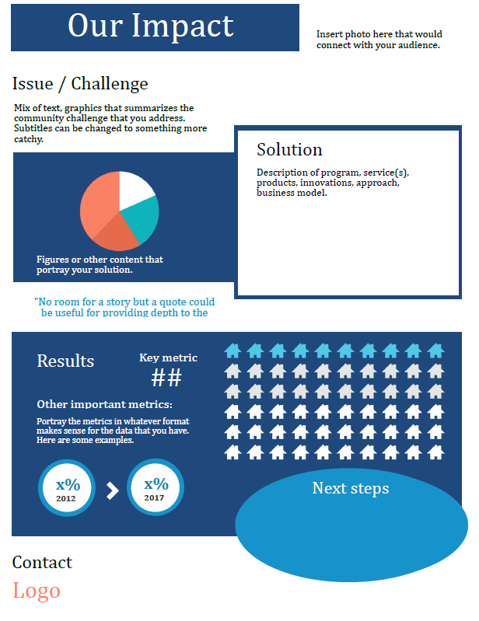
Design Tools
A Snapshot can be designed with different tools depending on your budget and needs. Once you design a Snapshot, you can easily create versions of it to suit other audiences. For instance, a Snapshot that is developed for an Advisory Board could later be adjusted to serve as an Impact Report but changed to include less detailed data more suitable to a public facing document.
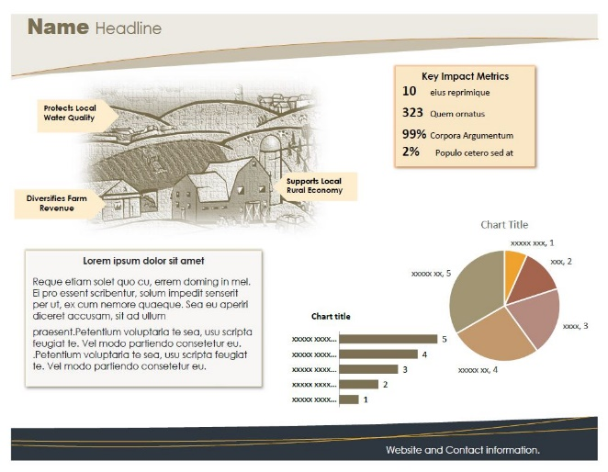
You can use a professional graphic designer to create a Snapshot or design it yourself. There are many software programs out there that feature intuitive, drag-and-drop design features, including office programs that you may already use, graphic design programs and interactive data visualization / business intelligence solutions. These are described in more detail below. You can start by designing something that is basic and move to a more sophisticated design later. Like any effective communications tool, the substance of what you present is the most important, and it may take a few iterations to develop a succinct and effective way to convey what you do, and why it is important.

Office Software Suites
You likely already use programs like Microsoft Word, Excel, PowerPoint, or similar programs such as Google Docs. These programs have built-in graphic design features that have become increasingly sophisticated over time. You can also embed data in charts or link a figure in a Word or PowerPoint file directly to data in spreadsheets.

Some things to consider about this option:
- While there are some excellent design features in these programs, if you are not fully familiar with them, they can be frustrating at times to use. Web tutorials are a good place to learn. This guide also provides some tips in Appendix A.
- The file size can get quite large. Sometimes this affects the performance of the program. It’s a good idea to close anything else that you may be working on.
- It is very easy to copy and paste parts of the Snapshot into other documents, presentations and e-mails.
- The image quality will not be as sharp as other options, but they are still pretty good, especially if any photos that you include are high resolution. You can save them as PDF or as graphic files such as JPG and PNG.
The Demonstrating Value website includes a number of different templates at www.demonstratingvalue.org/snapshots. Click on the name of the template to find the downloadable files that include both the template and instructions. While the templates are designed in Microsoft Word, these could be adapted to Google Docs.
Graphic Design Software
There are many software solutions out there for designing, developing, and publishing graphical content for web and print. While some of these are quite technical – such as solutions within Adobe’s Creative Cloud like Adobe Illustrator – a number of them enable less skilled users to create graphic design for Infographics and reports using drag-and-drop features. Examples of the latter include Piktochart, Venngage and Easelly. Some things to consider about this option:
- These programs enable you to produce very high-quality graphics.
- The drag-and-drop options have many Infographic and report templates that provide and excellent starting point.
- Most programs are cloud-based (you do not need to install them on your computer and are instead accessible through a website). Some programs allow you to connect with data in Google Drive and/or Dropbox.
- In terms of the cost, many drag-and-drop solutions offer a ‘freemium’ payment model which enables you do some basic creation for free, with a paid subscription for more frills. Check for discounts for non-profits.
- The drag-and-drop programs, and the companies associated with them, are new and the landscape is changing. Using a smaller vendor can carry some risk that they will not stay in business.

Interactive Data Visualization / Business Intelligence Solutions
Interactive Data Visualization Solutions (often known as Business Intelligence Solutions) produce dashboards that present data interactively: the reader can select and focus in on specific data that are important. These programs also allow users to connect to many data sources at the same time. Examples include Tableau, Clicdata, Zoho Analytics, Looker, iDashboards, and Sisense. Some considerations:
- A user can ‘slice and dice’ data, and test different assumption by manipulating input parameters. This is useful when you have large datasets. Visualizing the data helps users gain insights that they might not gain in other ways.
- Data connections can often be established in ‘real-time’, a helpful feature if you need to see updates frequently.
- The learning curve can be significant, but a user comfortable with databases or more advanced features in spreadsheets can adapt to these programs easily. No programming is required, and design is simplified with a drag-and-drop interface.
- Many companies that offer these programs are start-ups and the landscape is changing. Using a smaller vendor can carry some risk that they will not stay in business.
- Many solutions are cloud-based and licensed monthly or annually. Some are targetted to corporate clients and can be expensive. Others are directed at smaller-scale users. Many companies offer significant discounts to non-profits organizations for basic versions of their product. A great place to check for discounts is with TechSoup which connects charitable non-profits with donated and discounted technologies.

Impact Measurement Solutions
More and more software tools are emerging that support users to define and measure impact. Some tools enable users to create a theory of change about impact, define indicators and to create and download reports (PDF documents) to show impact. Examples include CSI Impact Dashboard and Global Value Exchange.
On-line integrated Measurement solutions to defining, collecting and reporting on impact including Sopact Impact Cloud, SAMETRICA, Sinzer, Social Return Intelligence Suite, Efforts to Outcomes. The price point varies – many solutions are directed to investors/funders who invest in these systems or to larger, social service organizations.
The Common Approach to Impact Measurement is developing an open impact data standard that would allow data to be shared, aggregated and compared across multiple data solution providers.

Step 5: Using and Improving your Snapshot
Once you have an Initial Snapshot, get feedback to ensure the information you present is clear, user friendly, and relevant. Keep in mind that the Snapshot is a tool that can be fine-tuned and enhanced over time to reflect changing needs. The important thing is to get a functional Snapshot that can be immediately applied.
As an external communications tool, the Snapshot is intended to become a useful document to engage a partner, funder, investor and other audiences in the importance of your work. Ideas for applying the Snapshot include:
- Adding it as an ‘annex or appendix’ to standardized report you may already do for a funder, to showcase more fully the value of the work you do.
- Making it available on your website.
- Use it as part of a printed information package.
- Using graphical elements of the Snapshot in a presentation or pitch.
- Printing a poster that can be displayed.
As an internal management tool, the Snapshot is intended to become a useful document to engage stakeholders in decision-making. Ideas for applying the Snapshot include:
- Using the Snapshot as a reporting tool to an executive team, advisory committee or board of directors. It can help initiate conversations about outcomes and what may be driving results. It can also suggest where to dig deeper through evaluation and research.
- Comparing performance and impact over time. Tracking key measures over time can provide a basis for target-setting for objectives.
The Snapshot which you have now developed is something that you can add to over time. In developing your Snapshot, you likely identified information that you would like to develop, but don’t have right now. In this step, plan out what you would like to do in the future. It can be useful to think of this in terms of:
- What is of most benefit to gather in the future? Consider this from the perspective of all stakeholders who defined the information. Are there things that are logical to do first? Are there things that would be nice to have, but are not critical?
- How much effort will it take to develop this data? Do you have a mechanism already in place, or can you develop one easily? What are the time and skills required collect, manage, and analyze the information? Will gathering these data be intrusive by participants? Are there language or literacy challenges? Are you trained in the method, or will you need help from an outside consultant?

The following grid can help you prioritize.
 |  | Collection Challenge
Importance of Information |  | Easy | Feasible | Difficult
 | High | 3  Definitely Collect | 2  Worth Collecting | 2  Consider an Alternative
 | Medium | 2  Worth  Collecting | 1  Collect if have time | 1  Collect if have time
 | Low | 1  Collect if have time | 1  Collect if have time | 0  Ignore

Use Worksheet D to plan out how you can develop additional data and evidence that will strengthen your Snapshot.
For more guidance on improving data collection, see the Demonstrating Value activity guide, Performance and Impact Measurement which can be found at: www.demonstratingvalue.org.

WORKSHEET D: Data Development Plan
1) Document your information sources
Document the performance measures (and other evidence) that you have included in your Snapshot, including its source and how frequently you will need to update it. A Comments column is also included to make any notes, such as guidance on how data should be interpreted.
Performance Measure / Evidence | Source | Update Frequency | Comments

Add in more rows as needed.
2) List any ideas for additional evidence, or improvements to the evidence in the table above.

NOTES

APPENDIX A

Tips for Designing in Microsoft Word
Most people are familiar with Microsoft Word but may be less familiar with its graphic design features which are quite robust. The availability of Microsoft Word makes it an easy first step for designing Snapshots. All design features are available across the Microsoft Suite of Programs, such as PowerPoint and Excel. The following tips can help you use these graphic design features.
- Use Text Boxes with a ‘Wrap Setting’ that is ‘In Front of the Text.’
This makes it much easier to move around and print. To do anything to a text box, including editing text, you must select it first with a mouse. When you do this, lines appear with square boxes at the corners and halfway points.
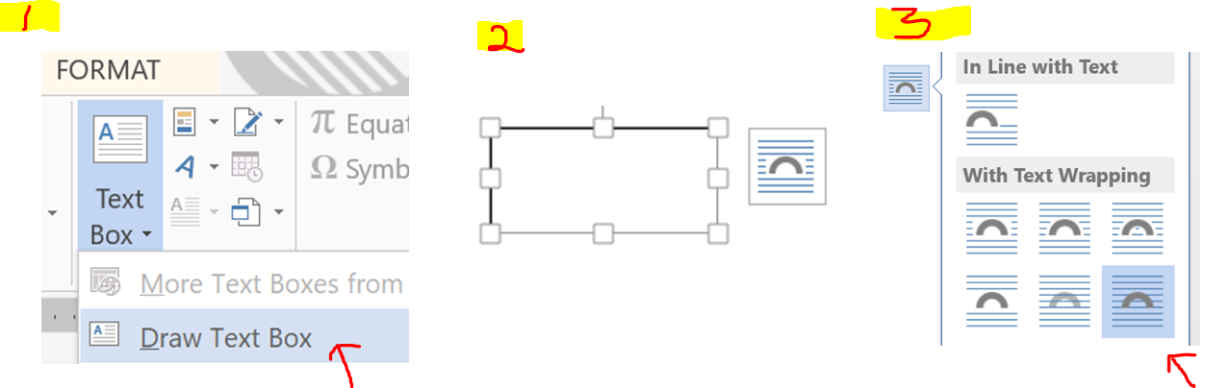

- Set any other content that you add such as images and figures to ‘In Front of Text’ as well. This makes it so you can easily move all components of the Snapshot around on the page.
- Generally, stay away from the ‘Smart Art’ feature. It makes the file size quite large and can be challenging to manipulate. It is usually easier just to draw figures directly.

- You can easily change the shapes of objects by using the ‘Change Shape’ feature under the Format tab in the Drawing Tools Ribbon that appears when you select the shape.
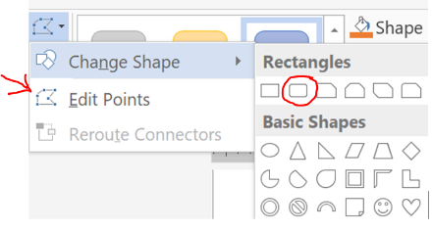
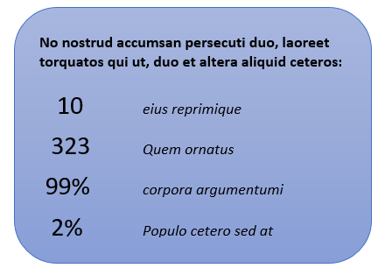
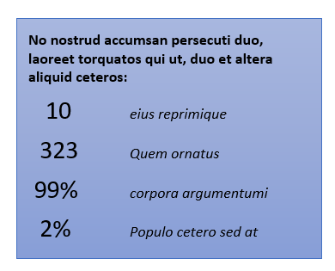
You can easily change the look of all the content using the ‘Design’ tab on the Ribbon. You can do this by selecting the Themes, Colour on the Design Tab. Colors, Themes and Fonts are all customizable so that you can match your organization’s branding. Further refinements can then be made to font and colour choices.

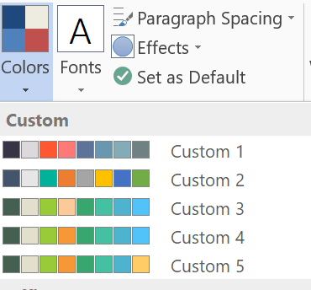
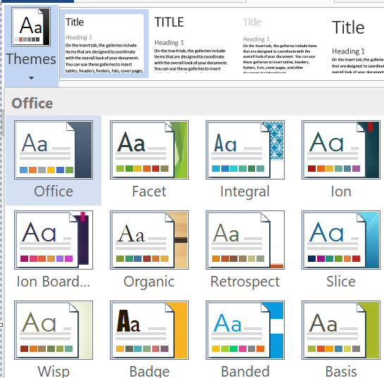
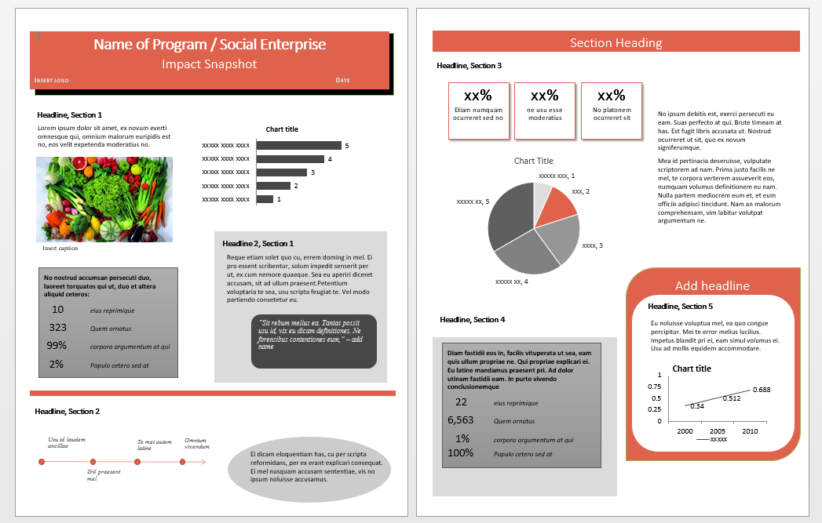
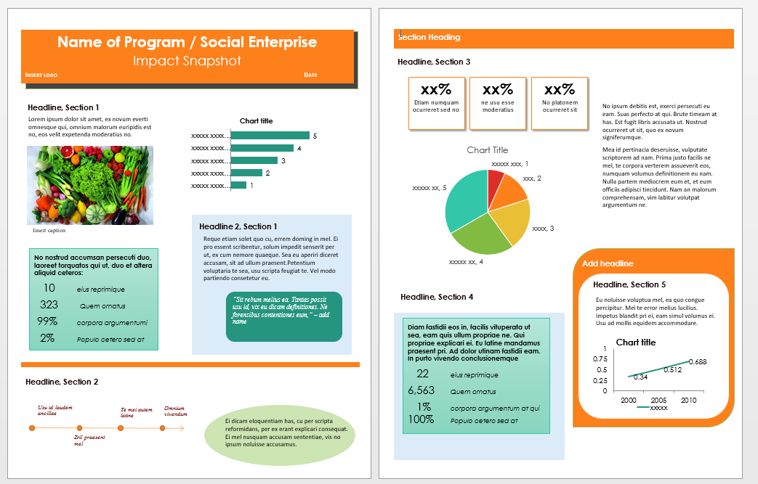

- Publish by saving (or printing) as a PDF or creating an Image file. Saving or printing as a PDF is possible in Word. While there is no easy way to save your file as an image within Word, you can use the Snipping Tool to select all or part of your Snapshot. This is a desktop App on Windows. You can also use ‘Print Screen (PrtScr)’ on you keyboard and then open and paste it into Paint, another desktop app. You can then crop and save the image into the image file type that you prefer.

