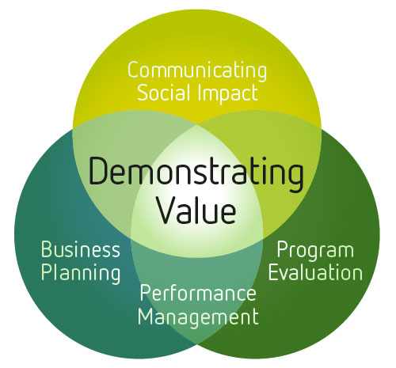 | WORKSHEET:  Identifying and Measuring Hidden Costs and Contributions

Introduction
This worksheet is designed to help you identify and measure hidden costs and contributions, which are costs that may be important to understanding your financial performance and sustainability, but which you may not consider because you do not pay for them directly. If these costs are integral components of your business activity, then they should be accounted for in order to reflect your true cost picture. This is particularly important when determining a competitive pricing policy or future funding needs to sustain your business in the long term.
This concept is covered in more detail in the Demonstrating Value Guide: Financial Intelligence, A Guide for Social Enterprise. You can integrate these costs into the True Cost Picture Workbook, an Excel spreadsheet that provides a step-by-step process for “adjusting” existing financial records to present a “double bottom line” picture of enterprise performance. These tools are available in the Tools and Resources section of the Demonstrating Value website (www.demonstratingvalue.org)
Ultimately, you will want to capture these costs in your accounting system by adopting appropriate allocation and valuation policies.

How to Identify and Quantify Hidden Costs and Contributions
A worksheet is provided at the end of this document to help you in identifying and quantify hidden costs and contributions. The worksheet can be completed by following the following steps.

Step 1
Brainstorm and identify non-cash contributions that you have received that are significant to your organization. Be sure to involve the appropriate staff in this exercise including accounting and operations people.
Are these contributions used in the normal course of your business? That is, would you have purchased them yourself if they were not otherwise provided? See page 3, for prompts that can help you with your brainstorming.

Step 2
Assess the likely magnitude of each contribution – its significance in terms of financial resources and importance to the program objectives. Don’t get caught up on things that will not have real impact on your true cost picture.

Step 3
Outline the methodology that could be used to value the contribution – either by applying appropriate market rates or, in the case of contributions of resources by your non-profit parent, based on a reasonable allocation method.

Step 4
Consider the challenges associated with valuing a contribution. This cost should only be included if fair value can be reasonably estimated.

TIPS:
- Principles to remember and apply – materiality, relevance, measurability
- Don’t get caught up in identifying costs that may not make that much difference to your true cost picture

The following prompts may help in identifying and estimating contributions:

- Do you receive donations of materials or purchase discounts because of your mission? Is it possible to estimate the value of these donations by estimating a comparable market value?

- Do you have volunteers, students or unpaid interns providing labour to produce goods/services in the social enterprise? Is it possible to estimate the value of volunteer hours? For more information on how to estimate the value of this labour see:

- Heritage Canada, How To Estimate the Economic Contribution of VolunteerWorkhttp://www.nald.ca/FULLTEXT/heritage/ComPartnE/EstVolE.htm

- Canadian Centre for Philanthropy, Estimating and Reporting the Value of Volunteer Contributions http://sectorsource.ca/sites/default/files/resources/files/Quarter_Estimating_Reporting_Final.pdf

- Does your parent organization provide or contribute towards any costs that are not included in your income statement? These could include:
  - shared receptionist service
  - advertising, website design, web site hosting
  - promotional material design and printing
  - facilities rent, utilities - hydro/heat/water
  - telephone, internet access, cell phones, office supplies
  - management staff costs & benefits, staff recognition
  - staff
  - accounting services, legal services, human resources services
  - printer/paper supplies, printer/copier rental, printer/copier maintenance
  - vehicle lease/rental vehicle insurance, vehicle gas, vehicle repairs
  - counseling service

- Consider capital assets (for example manufacturing equipment) used in your operations. Were any of these assets donated or purchased below market value and will they eventually have to be replaced? Is the depreciation of those assets included in your income statement?

WORKSHEET:
Identify  Non-Cash Contributions | Normal Course?  Y/N | Impact  H-M-L | Valuation  Methodology | Reliable Measure?  Y/N
e.g. Program Director salary and benefits not allocated to the enterprise | Yes | High | Based on time estimate of program director – 20%, half of this is for business management, half for program direction, grants, etc. | Yes

