PERFORMANCE AND IMPACT MEASUREMENT
An Activity Guide to
Improving your Practices
November 2020

About
The Demonstrating Value Initiative is a collaboration of community sector organizations united by the common interest of developing more accessible performance measurement and impact assessment methodologies for community The initiative, led by Vancity Community Foundation, engaged 20 social enterprises and investors between 2007-2009 in a process to develop and pilot a measurement framework. The framework has since been adapted to meet the needs of non-profit organization more broadly.
The initiative received financial and technical support from the following organizations: Coast Capital Savings, Community Economic Development Technical Assistance Program (CEDTAP), Enterprising Non-Profits (enp), Human Resources and Social Development Canada (HRSDC) and Renewal Partners, SAP Canada and Vancity Credit Union.
This guide and other tools that are available on the Demonstrating Value website are based on this framework. In 2013, a non-profit society, the Demonstrating Value Resource Society, was set up to extend the work of the Demonstrating Value Initiative.
This guide, initially known as the Demonstrating Value Workbook, was developed by Bryn Sadownik and has been updated over the past 10 years. In 2020, it was separated into two complementary resources: Developing a Snapshot and Performance and Impact Measurement.
Further copies of this guide can be downloaded at www.demonstratingvalue.org.

Guide Contents
Introduction 1
Define. Developing a Clear Picture of your Information Needs 4
Introducing the Demonstrating Value Framework 4
Applying the Framework to Assess Your Information Needs. 7
Collect. Strengthen your Data Collection 20
Data Collection Approaches 20
Troubleshooting Common Data Tracking Challenges 23
Use. Improving how you use your Information 25
Going Further 28
NOTES 29

Activity Steps & Worksheets
Step 1: How is Information Used? 7
Step 2: What Information is Useful? 10
Step 3: Develop and Prioritize a List of indicators 18
Step 4: Describe Data Collection Methods 20
Step 5: Making Sense of Your Data – Knowing What Your Data Can and Can’t Do 25
Step 6: Showing What you Know 26

WORKSHEET 1. Define your Stakeholders and their Needs 9
WORKSHEET 2. Define Useful Information 13
WORKSHEET 3. Indicator Record 19

Introduction
Imagine having information at your fingertips. The next time you are faced with an operational issue, or are deciding on key strategic directions, developing a funding application/report, or are showcasing what you do, you can easily pull up the information you need and show it in an engaging way.
This module can support you in developing monitoring and reporting systems that truly meet your needs. It has been uniquely designed for community-based organizations, that includes impact businesses/social enterprises, public and non-profit programs and initiatives that make a difference in their community. You can use it to systematically assess what information you need to run your organization, how you are collecting it, and ultimately how you can make the most use out of it.
Why do you want to do this?
- You have many levels of partners, stakeholders and clients to engage, and need to be efficient and effective in the data you collect and use.
- You are spending a lot of time on measurement and reporting. At the same time, you don’t always get the information you need for your decision-making and planning.
- The data that you pass on to others, doesn’t tell the whole picture.
- You have a new initiative. You want to be able to learn from what you are doing in a structured way and shift course if you need to.
- You want to be able to ‘measure your impact’ but are not sure how. You see how your organization creates value and impact, but it is challenging to express this to others who are not directly involved.
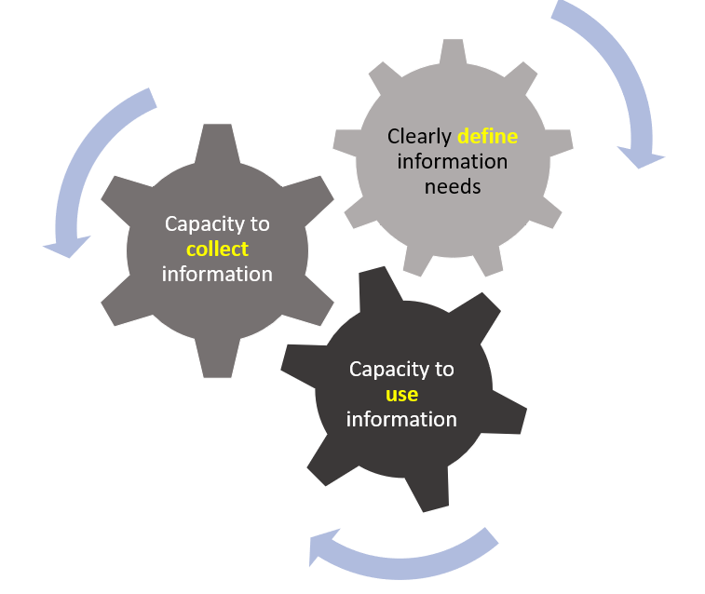
Demonstrating Value’s approach to performance and impact measurement is based on the premise that the information you gather in your organization must be directly relevant to the decisions you make and be compelling for others to learn about your value. To do this, you need to clearly define your information needs. You also must have capacity to both collect useful information and to put the information to good use. This module will walk you through three components of effective measurement.
- Clearly defining your information needs.
- Improving your capacity to collect information.
- Improving your capacity to use information.
This module includes:
- Concepts to help you think about your organization's performance and value.
- Guidance on what to monitor and how to use the information effectively using a process to review your monitoring, data collection and reporting systems.
- Links to additional tools and resources to help with this process.
We recommend working through the exercises in this activity guide with a cross-section of people involved in your organizations. You can do this in a workshop, a series of meetings or through targeted consultations. This activity guide can be used by itself or in conjunction with Demonstrating Value’s other Getting Started Toolkit resource: Developing a Snapshot - Communicating your Value (demonstratingvalue.org). Use both activity guides if you have the time and desire to develop polished and engaging communication tools in addition to refining performance and impact measurement.

The Common Approach to Impact Measurement
Demonstrating Value’s framework fits in with the Common Approach to Impact Measurement, a new, developing standard to impact measurement in Canada. This is a flexible standard that provides a foundation for sector-wide impact measurement and reporting. By using Demonstrating Value to strengthen your measurement capacity, you are also implementing the Common Approaches, and positioning your organization for impact investments, gaining new value-driven customers, and reporting more easily to your Board or funder. Where relevant in this workbook, we reference the Common Approaches using the Circle Icons on the next page that can easily allow you to connect with other Impact Measurement resources that are also aligned with the Common Approach. You can learn more about the Common Approach at their website:
https://carleton.ca/commonapproach/common-foundations

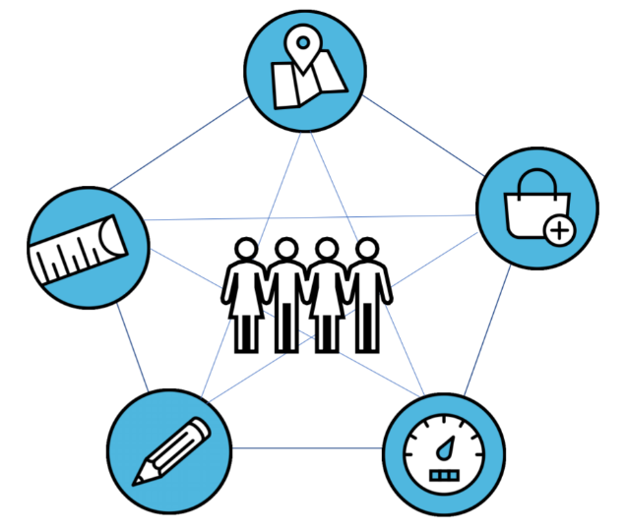
Plan your change
Use performance measures
Collect useful information
Gauge your impact
Report on results

Define. Developing a Clear Picture of your Information Needs
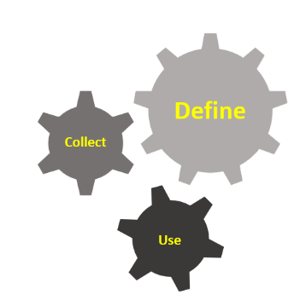
Having a clear picture of the information you need is an important starting place for guiding what data you collect and how you ultimately use it. In this step you will learn about the Demonstrating Value Framework and apply it to assessing what you should be collecting. The Framework will provide direction on how to measure the performance and impact of your organization (or specific initiative). This is done by working out what data and other information are most useful to you in managing, planning and communicating the value of your organization.

Introducing the Demonstrating Value Framework
Determining what information is most useful to collect is a big task, but it can be simplified by considering this simple question:
What Do You Want to Know and Show?
In other words:
- What do you want to know about in your organization that would assist your ability to manage and plan?
- What are things that you want to show others about the value of your organization?
Two additional question can help you determine what to measure. ‘What information is useful?' and ‘How will information be used?' This is expanded by two lenses that bring what you should consider into focus to develop a clear picture of your information needs.

How is Information Used?
What Information is Useful?

How is Information Used?

An Operational Perspective - What information do you need to support day-to-day decisions by management and staff? For instance, what can help you stay on top of costs, quality, and delivery of your mission?
A Strategic Perspective - What information do you need to support strategic decisions that are often made by a governance body such as a board? This information needs to educate your audience about key trends and events that have occurred and insights into where you are going.
An Engagement and Accountability Perspective - What information do you need to foster and maintain support of the organization? This includes support by investors, community members, employees and beneficiaries of your mission. Some may have very limited knowledge of who you are and what you are trying to accomplish. The data that you present will need context and interpretation.

What Information is Useful?
A Community Impact Perspective - What information can tell you about the ability of the organization to successfully contribute towards the social, cultural and environmental objectives set out in its mission?
A Business Performance (Operational) Perspective - What information can tell you about the success of the organization from a ‘business’ perspective?
An Organizational Sustainability Perspective - What information can help you understand whether you are developing and maintaining resources to meet your purpose in the long run?

Applying the Framework to Assess Your Information Needs.
Applying the Demonstrating Value Framework to assess your information needs involves three steps. You will first apply the first Lens (How will information be used?) to look at your stakeholders and to understand their information needs. You will then apply the second Lens (What information is useful?) to develop a list of useful information that speaks to understanding and demonstrating the organization’s impact in community, tracking operational performance and meeting goals around organizational sustainability.

Step 1: How is Information Used?
Know your Stakeholders and their Needs
Different people involved in your initiative or organization are often called ‘Stakeholders’. Who these people are will vary depending on your work and your organizational orientation (e.g., as a for-profit or non-profit) These may include (but not be limited to):

Management
Board of Directors
Regulators
Customers
Beneficiaries
Clients
Participants
Employees
Volunteers
Donors
Funders
Investors
Shareholders
Team Members
Partners
Community-at-Large

In this step, develop a list of your key stakeholders and articulate what information they may be looking for, based on what is important to them, in other words, their ‘Information Needs’. For example, if a funder has supported a program based on its expectation that the program contributes to meeting an objective around reducing homelessness in the region, then this funder needs to see information that relates to the program’s impact in this area, and the how the program budget is being spent in support of this goal. Other stakeholders may have additional or different information needs. A board of directors may want to see whether the program is diversifying its funding source. Management may seek to develop a case for support and seek evidence and narratives that demonstrate the value of the program. A list of information needs is shown in the following example.

Stakeholder | Information Needs
Board of Director | To understand funding sources for the program are becoming more diversified.
Funder A | To track progress in reducing chronic homelessness.
Funder B | To receive outcome information on how the program is supporting marginalized youth to access and maintain employment.
Staff | To document stories and evidence that can enable staff to engage potential donors to support this program.

Providing stakeholders with the information they need can enable them to:
- Stay engaged and support the organization / initiative.
- Permit you to operate or to receive accreditation.
- Learn from you, especially about what works and what is important.
- Understand what is working well and what can be improved.
- Manage specific risks.
- Make informed decisions.
Now it is your turn to define your Key Stakeholders and the Information Needs that are most important to them. Use Worksheet 1 on the next page. At this time, do not define performance measures or metrics that these stakeholders may need. Rather, stay at a high level. To do this exercise you may want to:
- Look at documents that have defined your organization’s objectives and outcomes in planning, evaluation and fundraising.
- Research the mandates and performance objectives of funders and partners, to be able to relate what you do in terms of how you help them accomplish their goals.
- Reach out to your stakeholders to ask what performance and impact information may be important to them.

WORKSHEET 1. Define your Stakeholders and their Needs
Develop a list of your key stakeholders and articulate what information they may be looking for, based on what is important to them
Stakeholder | What Do They Need to Know?

Step 2: What Information is Useful?
What specific information can be useful in understanding and demonstrating your value?
Now that you have a good understanding of who you are gathering information for, we will now go into more detail about what information is useful, the other ‘Lens’ in the Demonstrating Value framework.
The process for identifying what is useful is based on first identifying goals that you have for your organization / initiative and then writing down what you would like to ‘know and show’ about those goals. This workbook does not provide guidance on setting useful goals, but ideally this should come from good planning work that has informed program design, strategy and business development. Good planning draws on research, experience and intuition. If you have recently engaged in planning or evaluation activities, and there is strong buy-in, you will have good goals and questions to inform this table. If you do not, you may want to take the time now to conceptualize your impact (for instance, by developing a ‘Theory of Change’) and/or your business and organizational strategy (by developing a ‘Business Canvas’, ‘Strategy Map’, ‘SWOT’ Analysis). See Box 1 and 2 for more information on methods and approaches.
Use the worksheet that follows (Worksheet 2) to define the information that is useful to you. The worksheet starts by asking you to list key goals as they relate to community impact, business (operational) performance and organizational sustainability. Be sure to include any goals that are relevant to your stakeholders in Worksheet 1. This is then used to identify what data (and other information) would be most useful to have on-hand to support your decision-making, learning and communication needs. The process looks like this for a hypothetical recycling enterprise that provides supportive employment to individuals who have complex barriers to employment.
Describe goals that relate to creating impact. These goals may relate to what you are doing (activities) and what changes as a result (outcomes).
To reduce the amount of waste in landfill.
To engage people facing employment barriers in meaningful work opportunities

The next step is to think about what you would like to know specifically about each goal that could guide your approach and how effective it is. Also think about what you want to show that may be useful to show your funding partners. Be curious about your goals and think about your strategies and your results.
In the example of the recycling enterprise, they may want to know the following questions in relation to their goals:
- Is the community participating in our programs?
- Are we diverting waste to re-use and recycling?
- Are we accommodating and adequately supporting the needs of employees?
- Are our employees moving beyond 'survival mode' to greater stability and independence?
Once you have defined what you want to know and show, you can define what information (data and other evidence) you should be gathering to answer those questions. Information can be numbers (quantitative data) or they can be excerpts from research, testimonials, narrative, images, short diagrams and other forms of information that can be useful in supporting what you want to know and show (qualitative data). At this point, you don’t need to identify the information in detail, or as a precise indicator, just brainstorm ways that you can show answers to the questions you ask. Include both what you currently collect and what you could collect in the future. It may be helpful to look at suggestions about specific content for different aspects of community impact (by mission areas), business performance and organizational sustainability in the companion DV resource: Indicator Library for Measuring Impact, Sustainability and Performance (which can be found at: www.demonstratingvalue.org/resources/getting-started-toolkit). In the example of the recycling enterprise, information that may be most useful to support their learning and communication needs are:
- Is the community participating in our programs?
- # pickups (or drop offs)
- participation rate (% of households that use program/ households with access to program)
- characteristics of those who participate (and those who may not)
- Are we diverting waste to re-use and recycling?
- # tonnes waste diverted
- recycling rate (total tonnes of recyclables collected by total tonnes of recyclables and refuse from the same region.)
- Are we accommodating and adequately supporting the needs of employees?
- # Interactions by area of support
- # referrals to other programs / services
- Are employees moving beyond 'survival mode' to greater stability and independence?
  - # of people that somebody can rely on for support in times of need
  - Change in employee self-efficacy (Belief in yourself that you can do something)
  - Examples of life changes
  - Sustainable Livelihoods (A framework to understand what ‘assets’ an individual has (not just financial), and how they are developing these ‘assets’ further to escape poverty on a sustainable basis.)

WORKSHEET 2. Define Useful Information
1a. Describe goals that relate to creating community impact. These goals may relate to what you are doing (activities) and what changes as a result (outcomes). |  | Sample Goals, Community Impact  - Improve awareness and engagement (around a specific issue)  - Shift people’s behavior and practices  - Build community capacity to…  - Improve quality of life and well-being  - More effectively engage different cultural groups, ages and genders.  - Expand the reach of the program.  - Engage people in the program more effectively.  - Influence policy change  - Inspire more people to act.  - Reach people beyond the core service area.  - Influence the standard of practice.  Impact-related goals depend a lot on your specific mission. For mission-specific guidance on measurement related to goals see DV’s Library of Impact, Sustainability and Performance Measures and other resources available on the DV Website Resources page.
1b What do you want to know and show about these impact goals?
1c. What data (and other information) are most useful to support your learning and communication needs?
2a. Describe goals that relate to business (operational) performance. These goals may relate to what you are doing (tactics) and the results you seek. |  | Sample Goals: Business (Operational) Performance  - Improve cashflow and pay bills  - Deliver products and services on time and on budget  - Improve safety  - Control key costs that affect profitability  - Improve service quality  - Increase profitability  - Increase sales  - Earn more from the assets you have  - Improve capacity utilization of equipment  - Improve efficiency  - Develop more effective marketing  - Renew your brand image; differentiate your image in the market  For additional guidance on measurement relating to business and financial performance (especially social enterprise) see DV’s resource library and blog:  www.demonstratingvalue.org/tools-and-resources  www.demonstratingvalue.org/DV-blog
2b. What do you want to know and show about these performance goals?
2c. What data (and other information) are most useful to support your learning and communication needs?

3a. Describe goals that relate to organizational (or program) sustainability. |  | Sample Goals  Organizational Sustainability  - Reduce dependence on short-term grants  - Reduce debt to a manageable level  - Diversify revenue sources  - To earn more from the assets you have  - Retain and support staff and/or volunteers  - Provide training, skill development and other learning opportunities for employees and/or volunteers  - Create an inclusive environment where learning is shared  - Enhance profile and leadership in the community  - Improve systems and processes to support our work  For guidance on measurement related to organizational sustainability goals see DV’s Library of Impact, Sustainability and Performance Measures and other resources available on the DV Website Resources page.
3b. What do you want to know and show about these goals?
3c. What data (and other information) are most useful to support your learning and communication needs?

Box 1. Planning and mapping tools – Community Impact
When it comes to conceptualizing the impact of an initiative, describing a Theory of Change is often used to strengthen planning, and to guide measurement and evaluation. A Theory of Change (and related mapping tools such as a Logic Model and Impact Map) helps people make connections between a desired change and the work on the ground to get there. It acts like a guidepost where you can look for early signs that change is happening. It also helps you interpret what you see and is useful in surfacing assumptions that you are making. Your organization has the most influence over short-term outcomes, and less influence as you move out to intermediate and long-term outcomes, as other factors also determine those outcomes. Here are 3 really simplified examples:
 |  | OUTCOMES
 | What you do | Short-term |  | Intermediate |  | Long-term
Advocacy | Define and promote issue.  Formation of alliances in community | Increased visibility of organization and the issue  Increased knowledge and support for the issue | Increased legislative support |  | Change in policy |  | Change in society because issue addressed
Training program | Clients enroll, attend and complete program | Increased skills, abilities and competencies | Increased ability to obtain work |  | Increased earnings  Increased social connections |  | Improved quality of life and well-being
Environmental education | Students enroll, attend and complete program | Increased knowledge about actions to reduce environmental impacts | Changes in values, behavior and actions |  | Changes in use of energy, water, materials |  | Improved environmental outcomes (relating to specific issue)
For further information about these mapping approaches, see Demonstrating Value’s resource (Impact Mapping Worksheet). Other great resources for mapping include: University of Wisconsin Extension (Logic Models); Betterevaluation.org (Describe the Theory of Change); Social Impact Navigator (The Logic Model and Its Components); Innovation Network (Logic Model Workbook) For complex societal issues ‘systems mapping’ and associated tools may be more useful, see FSG (Systems Thinking Toolkit).
Box 2. Planning and Mapping tools: business / organization
There are many tools that support organizational planning and performance measurement, focused around clarifying goals and strategy, as well with detailed planning. Here are a few popular tools.
- Business Model Canvas is a visual chart of ‘building blocks’ that describe the different elements of an organization such as key partners, key activities, key resources, value propositions, cost structure and revenue streams. It was initially proposed in 2005 by Alexander Osterwalder as a business planning tool and has been adapted to different uses including to social enterprises and non-profit programs.
- Strategy Map (including Balanced Scorecard) is a map that describes causal links between strategic objectives. Each strategic objective will contain associated projects to complete, processes or competencies, key performance measures and targets, and key risk indicators. The original formulation of the strategy map is based on ‘four perspectives’: financial, customer, internal and learning and growth and was originally developed by Robert S Kaplan and David P Norton.
- SWOT Map is a simple and popular tool to assess internal and external factors impacting and organization’s success according to identifying internal strengths (S) and weaknesses (W) of the organization and external Opportunities (O) and Threats (T) in the marketplace/ environment.
- Process Improvement Tools (like Six Sigma) refers to the procedure of analyzing, identifying and improving processes to enhance overall quality. There are a range of systematic approaches, methodologies and tools available to support process improvement.
For further information about these mapping approaches, see the Social Enterprise Institute (Social Business Model Canvas); Chartered Global Management Accountant (CGMA) (Strategy Mapping); MindTools (SWOT Analysis)

Step 3: Develop and Prioritize a List of indicators
You will now take the information that you have identified as being useful and refine this further as a list of indicators. Indicators can also be known simply as measures (sometimes performance measures or metrics, if they are purely quantitative). Summarize the information you’ve developed in Worksheet 2 in the new table in Worksheet 3. Then check to see if each of your indicators meets the criteria (Box 3) for what makes a good indicator? If not, refine it to satisfy those conditions.
Box 3. what makes a good indicator?
Useful indicators are those that:
- Can be easily interpreted and communicated by others.
- Are reasonable to gather.
- Represent both qualities of the change (how well), in addition to the quantities (how much).
- Can give insights about where you want to go, not just current or past performance.
- Can be compared - such as a budget or last year’s figures and/or a benchmark (if available).
- Are precise.

WORKSHEET 3. Indicator Record
Take the information that you described in steps 1c, 2c and 3c and refine this further as a list of indicators (performance measures) in column A. Add in additional rows into this worksheet as needed or you may wish to copy this table into a new document or spreadsheet and develop it there. Only fill in Column A right now (as part of Step 3). You will have a chance to fill in the remaining columns as part of Step 4 (page 14) after you have read through the section on data collection.

A. Indicator | B. What does this indicator tell you and where will it be used? | C. Data Collection Method | D. Collection Frequency

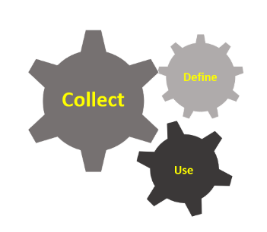
Collect. Strengthen your Data Collection
This section of the workbook provides guidance on data collection practices. You will then revisit the indicators that you described in Worksheet 3 to specify how you will collect this information.

Data Collection Approaches
Broadly there are two types of data collection methods: Qualitative Methods and Quantitative Methods. Qualitative methods are very useful for understanding personal experiences and specific settings. They can bring depth and nuance, and can communicate deep social and personal impact, experiences and how change occurs. Qualitative methods can take many forms – for instance, focus groups, interviews, case studies, story boards, journey mapping and open-ended questions in surveys. These methods in turn, yield data in a variety of forms such as written, oral and visual.
Quantitative data are numeric in nature. They are useful for understanding larger amounts of information in standardized ways. Quantitative data may come from direct measurement, record keeping and the use of closed-end questions in surveys like yes/no questions, Likert scales and ranking. These methods can be helpful for understanding things like frequencies, usage and satisfaction.
Both types of data collection are valid and useful. Using a combination of qualitative and quantitative data can strengthen insights into decision-making and reporting by ensuring that the limitations of one type of data are balanced by the strengths of another. It can also be important in allowing you to bring together a human element with numeric data. The most common collection methods are described in Box 4. An excellent resource for identifying and using methods can be found at Better Evaluation (‘Collect and/or Retrieve Data’).

Step 4: Describe Data Collection Method
In this step, revisit the table in Worksheet 3 (page 13) and fill in the remaining columns (B, C, D). As you select data collection approaches for your indicators, be sure to recall your original objective for gathering the information and your audience, as well as the resources (financial, time and expertise) you have available to support this. Data collection is integrated into many processes and systems already (e.g. point of sale, websites/digital media, human resources management, scheduling, contact management, to name a few) so knowing how to access and use this data can be a good starting point. Many software solutions allow you to add custom fields, and to export data and enhance reporting through third-party reporting software tools.
Sometimes you will need to collect new data. It is wise to think through different options for collecting data and to ask people within and outside of the organization, who would be involved in collecting and using data, for their input. One of the biggest success factors for implementing new data collection systems is buy-in from frontline staff, particularly for on-going monitoring. While strong leadership is important, frontline staff are the ones who actually fill out the forms and keep the records. They need to see the benefit of accurate data collection practices.
Be sure to choose a method that is manageable both in terms of the time involved, expertise needed and financial resources. Recall that both quantitative and qualitative data are valid. Once you have defined the type of data you’ll collect, choose appropriate methods based on your capacity and resources. For instance, if you are collecting qualitative data relating to social impact, story sharing and story boards are a straightforward way to get quotes and impact statements from participants that requires minimal analysis. For more depth, interviews and focus groups are excellent for understanding experience, context, and complexity but they may also require more resources and analysis before you can use them.
Box 4. Common data collection methods
Activity Log - Staff report of daily activities.
Anecdotal records - Stories and narratives about an event, an experience, or an individual, described by staff or participants.
Documentation - Administrative records of activities (e.g., inventory software, point of sales systems, reports, minutes of meetings, financial transactions etc.).
Evaluation Form - A set of questions that determine the participants’ opinions, attitudes, and understanding once an activity is complete.
Focus Group - Group discussions with a small number of selected people about certain questions.
Interview - A set of questions about certain topics that are posed to specific individuals.
Journal Recording - Self report of daily activities by participants.
Knowledge/ Skill Tests - A set of questions that determine the level of knowledge or skills in participants.
Observation Notes – Documentation of direct observation of activities.
Storyboard - A tool that is used to construct a visual representation of a person's narrative and his/her related context.
Story Sharing – A reciprocal exchange of stories to delve into meaning and impact.
Survey - A set of predetermined questions about certain topics that are answered by a target audience.
Now that you have all the columns filled out, it’s time to review the indicators, and consider which ones are ‘must haves’ and which ones are ‘nice to haves’. This can help you prioritize and remove ones that are less practical or which you may develop later if you have more resources. Look over your completed Worksheet 3, and reflect on the following to help you mark off which ones to keep, and which ones to set aside for the time being:
- What is of most benefit to gather? Consider this from the perspective of all stakeholders who defined the information. Are there things that are logical to do first? Are there things that would be nice to have, but are not critical?
- How much effort will it take to develop this data? Do you have a mechanism already in place, or can you develop one easily? What are the time and skills required collect, manage, and analyze the information? Will gathering these data be intrusive by participants? Are there language or literacy challenges? Are you trained in the method, or will you need help from an outside consultant?

The following grid can help you prioritize.
 |  | Collection Challenge
Importance of Information |  | Easy | Feasible | Difficult
 | High | 3  Definitely Collect | 2  Worth Collecting | 2  Consider an Alternative
 | Medium | 2  Worth  Collecting | 1  Collect if have time | 1  Collect if have time
 | Low | 1  Collect if have time | 1  Collect if have time | 0  Ignore

In Worksheet 3, move any indicators that you have determined are less important and/or are difficult to collect to separate table as a reference for what you can develop in the future as resources permit. Delete any indicators that fall into ‘0-Ignore’.

Troubleshooting Common Data Tracking Challenges
Once you have defined and implemented data collection, you need to organize and manage the data overtime. Like maintaining a building or car, taking the time to streamline, systematize and maintain data can save you a lot of time and money. Here are a few ideas for how to improve your data collection systems.
Making time to evaluate your existing systems and change course if needed.
You are likely already spending a lot of time and effort trying to pull together data and information, so by systematically improving what you do, you can ultimately save time and resources. Develop a project to evaluate how well your needs are met by your existing data tracking and management systems and investigate the pros and cons (benefits and costs) of a new system. It can be helpful to connect with other people in similar situations to ‘piggyback’ on what they’ve learned. Web forums and case studies may also be helpful.
Take the time to understand your needs, options and selection criteria before contacting a vendor. Make sure all those who need to be involved are consulted, including the end user.
Cleaning up and streamlining existing data
If you have ever found it challenging to pull out and summarize information, you will know how useful it can be to ensure information is accessible and understandable. People come and go, but often the spreadsheet and files stay. Here is some advice to clean up and streamline data.
- Archive or delete extraneous data. Take some time to develop some rules and follow them. If you develop data with a lot of inconsistency, for instance in how names are used, or abbreviated, learn about and apply validation rules, including how to include drop down lists in spreadsheets. If many people are working on the file, develop and follow conventions for how you edit information. When someone seeks to conduct an analysis of the data, have them make a copy of the file, so that the main dataset is kept ‘clean’.
- Spreadsheet programs have excellent built-in data analysis function such as Pivot Tables. To use them, you must format and record data in specific ways. The learning curve for most functions is easy and there are many learning resources.
- Recognize the limits of spreadsheets, particularly if they are becoming permanent systems for recording transactions and other on-going tracking. While spreadsheets are a low-cost and accessible tool, it is easy to accidently change the data and introduce other human errors. Databases are more structured and can handle many records. Reporting features are separate from the data, allowing you to retrieve, perform analysis and generate multiple reports with the same data without risk of impacted the integrity of the underlying data.
Box 5. Resources – better data management
Demonstrating Value Resources
- Calculate ROI for new Software Calculate a return on investment (ROI) for new software to make a case for purchase.
- Employment Support Tracking Tool Track and show the support you provide to target employees to help them succeed
- Guide to CRM Systems What to consider when you are choosing a Client Relationship Management System.
- Maintaining Privacy and Confidentiality Guidance on how to address privacy and confidentiality concerns in monitoring.
- Supportive Employment Positions Tracking Tool Track data relating to your employment relationship with 'targetted' employees.
- Financial Intelligence for Social Enterprises Introduction to financial management fundamentals for social enterprises
Other
- Tech Planning 201: Developing a Data Strategy This course helps you understand the major considerations around data and how you can answer them to move your organization forward with a tactical technology plan
- Nonprofit Data and Impact Measurement Mega Pack Start with the basics of Excel, walk through the process of selecting, collecting and analyzing data with our data experts
- GCF Learn Free Courses include effectively using MS Excel and Access.

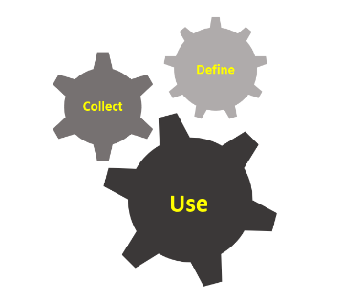
Use. Improving how you use your Information

You’ve defined what you need to know and made a plan to collect the information you need. Now it’s time to make sense of your data so you can use it effectively in decision-making as well as communicate it effectively to engage others. Data analysis can seem daunting and unwieldy. Being clear on the scope and purpose of the data is paramount. This workbook does not provide guidance on data analysis techniques – that is a large field that covers methods across a broad spectrum. This guide highlights some of the key points to consider as you decide who or how you will do your analysis.

Step 5: Making Sense of Your Data – Knowing What Your Data Can and Can’t Do
Different data collections methods will need different analysis methods. Understanding the strengths and limits of your methods, and your data, will allow you to clearly present and explain your impact, without trying to do more with your data than it supports.

Analyzing Text
If you have collected qualitative data, your main task in analysis is to look for patterns, connections, relationships or themes that emerge in interview or focus group recordings or transcripts. For example, themes that emerge in interviews with participants in an employment program could be how employees express improvements to their life stability and relationships. While you may have some idea of what you are looking for, let the themes emerge from your data. These can validate what you were hoping to show, signal areas where things are not effective, or reveal new opportunities to pursue. You are looking for the underlying meaning, or the personal experiences, being shared. Taking the time to get to know the content and allowing time for reflection and analysis is a crucial step in qualitative data. Be sure to account for this in your timeline and work process.

Analyzing Numbers
If you have quantitative data, you will likely be working with descriptive statistics. Descriptive statistics is the term given to the analysis of data that helps describe, show or summarize data in a meaningful way such that, for example, patterns might emerge from the data. They do not allow you to infer the reason or rationale for what is happening. Be sure to present your statistics as clear statements of what the data showed. Sometimes using wording very close to what was used in the original data collection tool is a helpful way to make sure to stay true to what the number shows. Any interpretation of the reason or cause for those statistics needs to be clearly identified as interpretation, not a finding, and explained or supported other ways.

Flip back to your completed Worksheet 3 and review your indicators and data collection methods. How will you analyze data? If you are collecting this data already, how well are you analyzing and synthesizing what you track? What improvements can you make? Do you have the resources needed for this? If you are not sure you have the means to complete the analysis, consider getting help to ensure you can, or setting aside that indicator or approach for another time. Two helpful resources for analyzing data are available on the Urban Institute website:
- Analyzing Outcome Information: Getting the Most from Data (Authors: Harry P. Hatry, Jake Cowan and Michael Hendricks; March 18, 2004)
- Using Outcome Information: Making Data Pay Off (Authors: Elaine Morley and Linda M. Lampkin; July 31, 2004)

Step 6: Showing What you Know
You’ve done the hard work of defining, collecting and analyzing your data. Now you’re ready to use it. There are multiple ways to communicate data and to integrate this into planning and decision-making. This includes:
- Enhancing current management processes with better data and evidence.
- Reviewing and improving reporting to stakeholders.
- Sharing and learning from the data across the organization.

It is important to be selective and thoughtful in how you use information. Provide context and interpretation as needed. Recall that you collected data to learn something specific and that you seek to use the information to engage particular audiences. Box 5 provides general tips on how to effectively use data. Demonstrating Value also provides in-depth guidance to developing a communications tool to show what you know in Developing a Snapshot: Communicating your Value, which can be found at demonstratingvalue.org.

Box 5. Tips for Using data
- Think about your audience – how do they prefer to receive information? Is it text, graphics, numbers, written, visual or a mixture of all of these? Use plain language as much as possible (avoid acronyms unless your audience is very familiar with them) and use a concise writing style that ensures accessibility to the information for everyone. Be careful to remove visual elements that do not contribute to the main message. Depicting data in compelling figures can encourage insight and application of your findings.
- If you picked interviews or story sharing methods, look specifically for direct, clear, and reasonable short quotes that demonstrate value and impact.
- If you undertook focus groups to understand programming strengths, review the focus group content looking for patterns and trends – themes – that show broad areas of strengths or successes. Share them by explaining how they support your objectives and demonstrate your value and impact.
- Use images that speak to the specific points you are trying to share. Let the image draw the audience in, encourage connection, or punctuate the message. As needed, use complementary text to explain more about what you are showing, and why it is important. Participant-generated art can also be an extremely effective way of communicating the impact of programming and can elevate the impact of reporting.
- If you used survey methods and have descriptive statistics, look for the statistics that speak most directly to your goals and indicators. Consider usage changes, increases or decreases in participant enrollment, or overall satisfaction ratings. Remember, you cannot use descriptive statistics to infer reasons or rationales. Be clear with the numbers you are presenting, supporting any description or analysis of what the numbers may mean with qualitative data, or existing information.

Going Further
This activity guide supported you to assess what information you need to run your organization (or initiative), how you are collecting it, and ultimately how you can make the most use out of it. Demonstrating Value’s approach to performance and impact measurement is based on the premise that the information you gather in your organization must be directly relevant to the decisions you make and be compelling for others to learn about your value.
It is critical to develop measurement systems that can be reasonably supported by your human resources, technical and financial capacity. Starting with a simple and manageable system that can be strengthened over time is ultimately better than a sophisticated and expensive system that proves to be unwieldy and is abandoned. Measurement systems that take root successfully are also those that reflect and respond to the needs of people across the organization, including the front-line staff who are often the ones most involved in data collection.
The collection and effective use of information is an on-going process that needs to be nurtured, maintained and strengthened. Any of the three components covered in this guide - 1) defining information needs, 2) strengthening your capacity to collect information, and 3) using information in management and communications – can be strengthened over time. Additional resources to assist you can be found both in the sections of this activity guide, on the full Demonstrating Value website (www.demonstratingvalue.org), and referenced by other partners of the Common Approach to Impact Measurement (ccednet-rcdec.ca/en/page/common-approach-impact-measurement).

NOTES

To do this, you require data that is obtained by probability sampling in which the people that you are asking to respond to the survey are chosen at random.

